

SMART LIBRARY MANAGEMENT, BOOK RESERVATION AND OVERDUE NOTIFICATION SYSTEM USING JAVA

Assignment Information
Particular | Details
Department | Artificial Intelligence
Programme | CSE
Course Code & Name | CSA0904 – Programming in Java (SLOT A)
Academic Year / Batch | 4th year - 2027
Faculty Name | Dr. Thalapathi Rajasekaran R
Assignment Title | Smart Library Management, Book Reservation and Overdue Notification System using Java
Date of Issue | 01-09-2026
Date of Submission | 02-09-2026
Maximum Marks | 100
Course Outcomes | CO1, CO2, CO3
Bloom's Taxonomy | L2 – Understand; L3 – Apply; L4 – Analyse
SDG Mapping | SDG 4, SDG 9, SDG 16
Industry / Societal Relevance | Digital library circulation, resource tracking, reservation management, automated notifications and reliable concurrent transaction processing
The supplied assignment identifies CO1 for object-oriented programming, CO2 for Java Collections Framework, and CO3 for multithreading and exception handling.

1. Problem Statement and Problem Formulation
1.1 Problem Statement
The objective of this project is to design, implement and evaluate a menu-driven Java application for a Smart Library Management, Book Reservation and Overdue Notification System.
The system manages library members, books, borrowing, returning, reservations, fines and notifications. It maintains the availability of limited book copies and ensures that concurrent requests do not create inconsistent inventory.
The application provides facilities to:
- Register members.
- Add and update books.
- Display available books and copies.
- Search books and member records.
- Issue and return books.
- Calculate overdue fines.
- Reserve unavailable books.
- Maintain reservation waitlists.
- Cancel reservations.
- Generate due-date and overdue notifications.
- Generate circulation and inventory-utilization reports.
- Handle invalid inputs and exceptional situations.
- Demonstrate multithreading, synchronization and inter-thread communication.
The supplied question specifically requires classes such as Member, Book, Reservation, Inventory and Notification, along with inheritance, polymorphism, collections, generics, iterators, exception handling and multithreading.

1.2 Problem Formulation
Inputs
- Member ID
- Member name
- Email
- Membership type
- Book ID
- Book title
- Author
- Category
- Number of copies
- Issue/return requests
- Reservation requests
- Search/update values
- Date information
Processing
- Validate member and book details.
- Store members and books using Java collections.
- Check member borrowing limits.
- Check book availability.
- Issue books and create loan records.
- Return books and calculate fines.
- Maintain reservation queues.
- Generate due-date and overdue notifications.
- Process concurrent requests using synchronized operations.
- Use wait() and notifyAll() for inter-thread communication.
- Generate circulation and inventory-utilization reports.
Outputs
- Member records
- Book inventory
- Search results
- Issue/return confirmations
- Due dates
- Reservation queue
- Fine amount
- Notifications
- Circulation report
- Inventory-utilization report
- Exception messages
- Concurrent processing results

2. Objective and Expected Outcomes
2.1 Objectives
- To apply object-oriented programming concepts to a practical library-management problem.
- To implement encapsulation and data hiding.
- To demonstrate inheritance and runtime polymorphism.
- To use Java Collections Framework classes such as ArrayList, HashSet, HashMap and Hashtable.
- To use generics, Iterator and ListIterator.
- To implement built-in and user-defined exception handling.
- To implement multithreading and thread priorities.
- To maintain data consistency using synchronization.
- To demonstrate inter-thread communication using wait() and notifyAll().
- To generate useful circulation, fine and inventory reports.
2.2 Expected Outcomes
After completing the project:
- Library members and books can be managed efficiently.
- Available book copies are tracked accurately.
- Different membership types can have different borrowing limits and fine rates.
- Unavailable books can be reserved.
- Duplicate reservations are rejected.
- Overdue fines are calculated automatically.
- Due-date and overdue notifications are generated.
- Concurrent book-issue requests are safely handled.
- Invalid operations are handled without terminating the program.
- Library reports can be generated from the stored records.

3. Requirements, Constraints and Assumptions

3.1 Functional Requirements
ID | Functional Requirement
FR1 | Register Student and Faculty members
FR2 | Add and update book records
FR3 | Display inventory and available copies
FR4 | Search books
FR5 | Issue books
FR6 | Return books and calculate fines
FR7 | Reserve unavailable books
FR8 | Cancel reservations
FR9 | Generate due-date notifications
FR10 | Generate overdue notifications
FR11 | Generate circulation reports
FR12 | Generate inventory-utilization reports
FR13 | Demonstrate concurrent book issue
FR14 | Handle invalid inputs and exceptions
3.2 Non-Functional Requirements
- Correctness: Inventory should remain consistent.
- Reliability: Invalid operations should be handled safely.
- Usability: The system should provide a simple menu-driven interface.
- Maintainability: Different responsibilities should be separated into classes.
- Performance: In-memory collections should provide quick access for the assignment-scale data.
- Safety: Shared inventory operations must be synchronized.
3.3 Constraints
- Java console application.
- JDK 17 or later.
- No external database required.
- Data is maintained in memory.
- Notifications are simulated through console output.
- Designed for an academic-scale dataset.
- Thread priority is not used as a correctness mechanism.
3.4 Assumptions
- Every member has a unique member ID.
- Every book has a unique book ID.
- Student members can borrow up to 3 books.
- Faculty members can borrow up to 5 books.
- Standard loan period is 14 days.
- Student fine rate is Rs. 2 per overdue day.
- Faculty fine rate is Rs. 3 per overdue day.
- A reservation is required only when no copy is currently available.

4. Application of Relevant Course Knowledge / Concepts
The project directly applies the three mapped course outcomes.
Java Concept | Application
Classes and Objects | Member, Book, Reservation, Inventory, Notification and other classes
Encapsulation | Private attributes with controlled methods
Data Hiding | Internal state is not directly exposed
Inheritance | StudentMember and FacultyMember extend Member
Polymorphism | Membership-specific behaviour is selected at runtime
ArrayList | Loans, members and reservations
HashSet | Unique member collection
HashMap | Fast member and book lookup
Hashtable | Notification records
Generics | Type-safe collections
Iterator | Searching/traversing collections
ListIterator | Reservation traversal/removal
Exception Handling | Invalid input and library-specific exceptions
Multithreading | Concurrent issue and notification tasks
Thread Priority | Different priorities assigned to concurrent tasks
Synchronization | Protects shared inventory
wait() | Waiting for book availability
notifyAll() | Notifies waiting threads after return
The rubric explicitly evaluates class design, inheritance/polymorphism, collections/generics/iterators, exception handling and multithreading/synchronization.

5. Design / Proposed Solution / Methodology
5.1 Proposed Architecture
The application follows an object-oriented architecture:
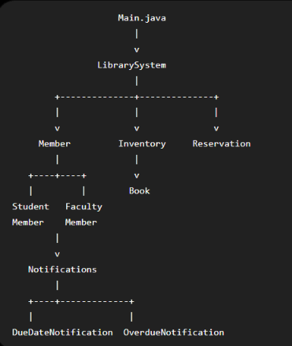

The system also contains separate thread classes:
ConcurrentIssueTask
AvailabilityWaitTask
OverdueNotificationTask
5.2 Major Classes
Class | Responsibility
Main | Menu-driven user interface
LibrarySystem | Controls the complete library workflow
Member | Base member class
StudentMember | Student-specific borrowing/fine behaviour
FacultyMember | Faculty-specific borrowing/fine behaviour
Book | Stores book information and stock
Inventory | Manages book inventory
Reservation | Represents a book reservation
Notification | Base notification class
DueDateNotification | Due-date reminder
OverdueNotification | Overdue message
ConcurrentIssueTask | Concurrent issue operation
AvailabilityWaitTask | Demonstrates waiting for availability
OverdueNotificationTask | Performs notification processing
LibraryExceptions | User-defined exceptions

6. Algorithm / Pseudocode / Flowchart
6.1 Main Algorithm
START
Load sample members and books
REPEAT
Display main menu
Read user choice
IF choice = Register Member
Validate input
Create Student or Faculty member
Store member
ELSE IF choice = Add Book
Validate book details
Add book to inventory
ELSE IF choice = Display Inventory
Display all books and available copies
ELSE IF choice = Search Book
Search inventory
Display matching books
ELSE IF choice = Update Book
Find book
Update required information
ELSE IF choice = Issue Book
Validate member
Validate book
Check borrowing limit
Check available copies
Synchronize inventory
Create loan
Update member record

ELSE IF choice = Return Book
Find active loan
Calculate overdue days
Calculate fine
Update inventory
Notify waiting threads
ELSE IF choice = Reserve Book
Validate member and book
Check availability
Check duplicate reservation
Add reservation to waitlist
ELSE IF choice = Cancel Reservation
Search reservation
Remove reservation using ListIterator
ELSE IF choice = Notifications
Check active loans
Generate due/overdue notifications
ELSE IF choice = Concurrent Demo
Create issue threads
Assign priorities
Start threads
Synchronize shared inventory
Demonstrate wait/notifyAll
ELSE IF choice = Reports
Generate circulation report
Generate inventory-utilization report
ELSE IF choice = Exit
STOP
Handle exceptions
UNTIL Exit
END
6.2 Fine Calculation
Overdue Days = Return Date - Due Date
IF Overdue Days < 0
Overdue Days = 0
Fine = Overdue Days × Fine Rate
Example:
Due Date = 15-09-2026
Return Date = 17-09-2026
Overdue Days = 2
Fine Rate = Rs. 2/day
Fine = 2 × 2
= Rs. 4
6.3 Reservation Algorithm
Validate member
Validate book
IF available copies > 0
Reservation not required
ELSE
Search existing reservations
IF duplicate exists
Throw DuplicateReservationException
ELSE
Add reservation to waitlist

7. Implementation / Source Code and Environment / Tools Used
7.1 Software Environment
Component | Details
Programming Language | Java
JDK | JDK 17+
Tested Runtime | OpenJDK 21
IDE | Visual Studio Code
Interface | Console
Compiler | javac
Runtime | java
Diagram Tool | Graphviz
Version Control | Git / GitHub
7.2 Compilation
From the project root:
javac -d out src/*.java
7.3 Execution
java -cp out Main
7.4 Source Code Structure
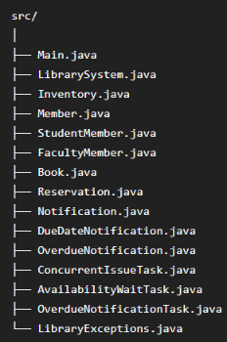

8. Test Cases and Expected / Actual Results
Test ID | Test Case | Expected Result | Actual Result | Status
TC01 | Display inventory | Books and copies displayed | Correct inventory displayed | PASS
TC02 | Search Java book | Java book displayed | B101 displayed | PASS
TC03 | Issue B101 to M001 | Book issued and due date generated | Successful | PASS
TC04 | Due notification | Reminder generated | Notification displayed | PASS
TC05 | Return overdue B101 | Fine calculated | Rs. 4.00 calculated | PASS
TC06 | Reserve unavailable B102 | Reservation added | Reservation added | PASS
TC07 | Duplicate reservation | Exception displayed | Duplicate reservation rejected | PASS
TC08 | Update B103 | Book details updated | Updated record displayed | PASS
TC09 | Invalid member | Exception handled | Invalid member message displayed | PASS
TC10 | Concurrent issue | Only available copy issued | One success, one rejection | PASS
TC11 | Waiting thread | Thread waits for availability | Thread resumed after return | PASS
TC12 | Utilization report | Report generated | Report generated | PASS

9. Execution Screenshots / Outputs
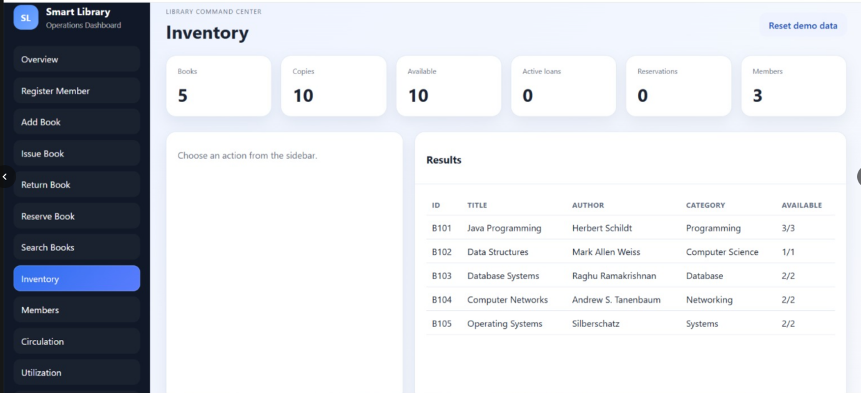
Figure 1: Displaying library inventory

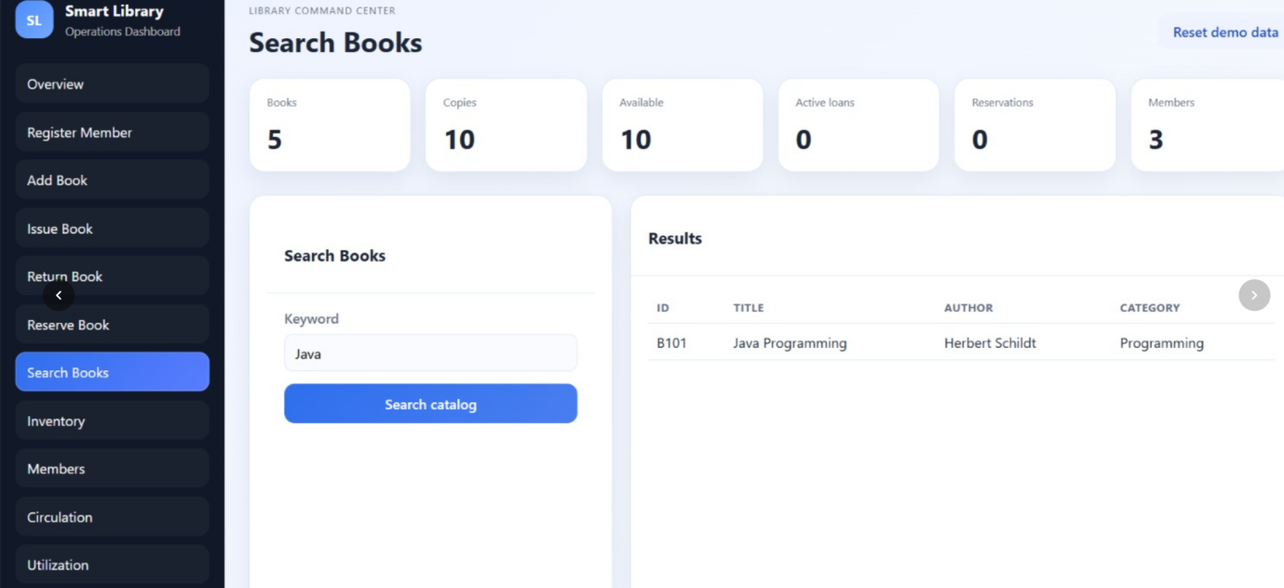

Figure 2: Search for books
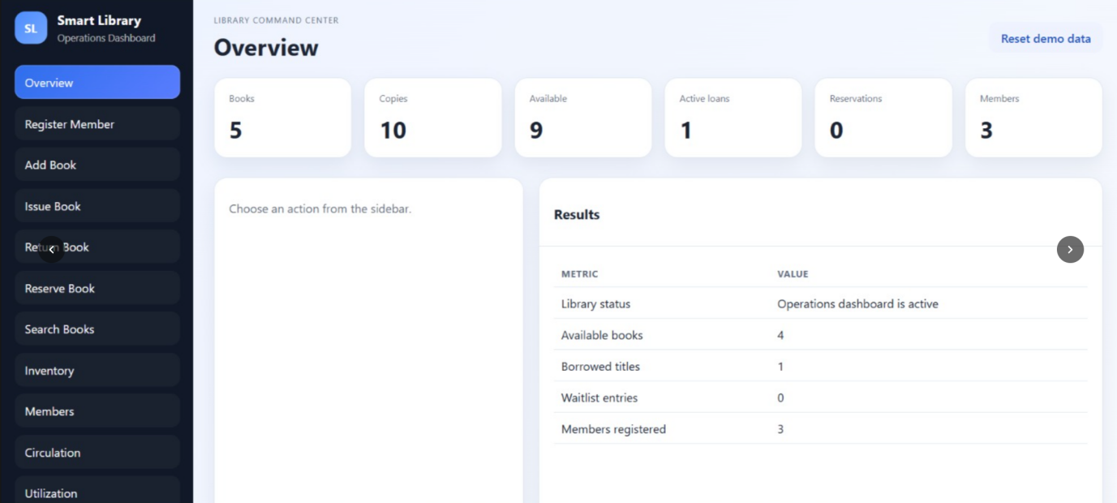
Figure 3: overview of dashboard.

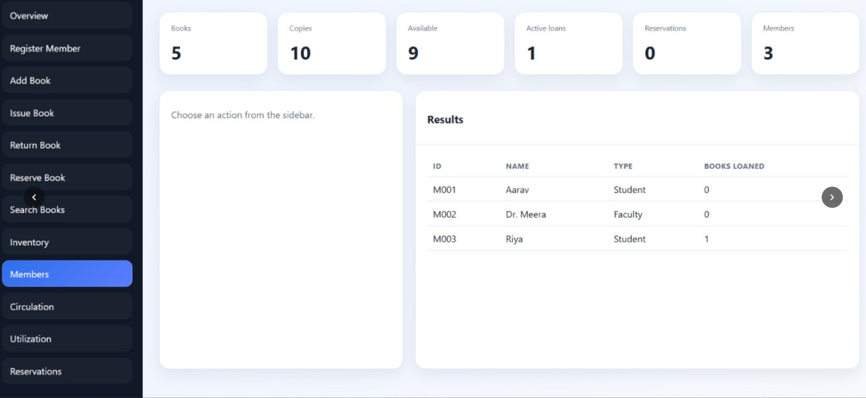
Figure 4: current registered students.
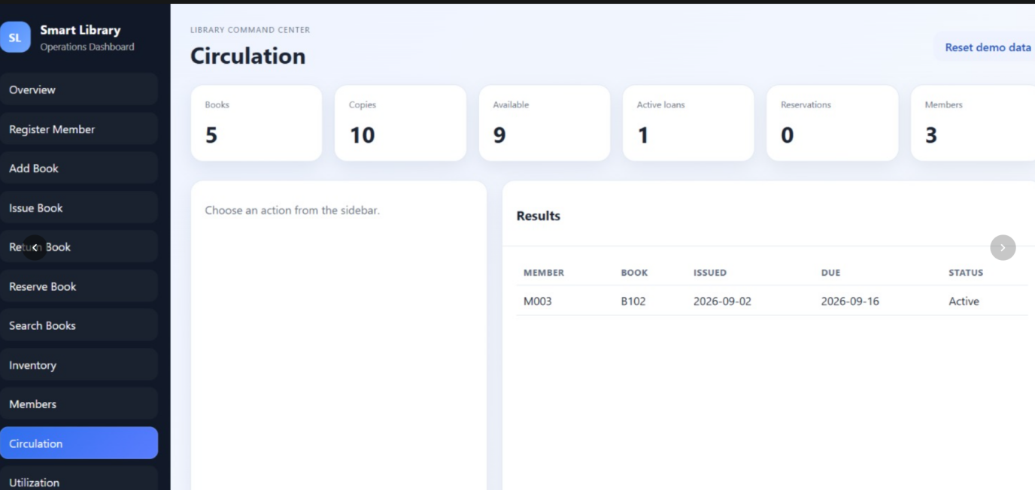
Figure 5: circulation .

10. Results and Validation
10.1 Functional Validation
Requirement | Evidence | Result
Member management | Member registration/listing | Satisfied
Book management | Add/update/search | Satisfied
Inventory management | Available-copy tracking | Satisfied
Book issue | Issue test | Satisfied
Book return | Return/fine test | Satisfied
Reservation | Waitlist test | Satisfied
Notification | Due/overdue test | Satisfied
Exception handling | Invalid input tests | Satisfied
Multithreading | Concurrent issue test | Satisfied
Synchronization | Shared inventory test | Satisfied
Inter-thread communication | Wait/notify test | Satisfied
Reports | Circulation/utilization reports | Satisfied

10.2 Fine Validation
Parameter | Value
Member | M001
Membership | Student
Book | B101
Due Date | 15-09-2026
Return Date | 17-09-2026
Overdue Days | 2
Fine Rate | Rs. 2/day
Fine | Rs. 4.00
The calculated result matches the program output.
10.3 Concurrency Validation
For the one-copy book B102, two concurrent issue requests were generated.
Observed behaviour:
Thread 1 → SUCCESS
Thread 2 → Book unavailable
The available-copy count did not become negative.
The waiting task subsequently waited for B102 and resumed when the book was returned and notifyAll() was invoked.
This validates synchronization and inter-thread communication.

11. Analysis, Comparison, Trade-offs and Justification
11.1 Comparison of Approaches
Approach | Advantages | Limitations | Selection
Arrays | Simple | Fixed size and limited lookup | Not selected
Single ArrayList | Easy implementation | Less suitable for uniqueness and keyed lookup | Not selected
Multiple Java Collections | Flexible, efficient lookup and directly supports CO2 | Slightly more complex | Selected
Database | Persistent and scalable | Requires additional setup and shifts focus away from core Java concepts | Future improvement
11.2 Trade-offs
In-memory storage
The current solution uses in-memory collections because they are simple and directly demonstrate Java Collections Framework concepts.
Trade-off: Data is lost when the program terminates.
Console notifications
Console output keeps the project self-contained.
Trade-off: It does not send real email or SMS notifications.
Synchronization
Synchronized methods provide a straightforward way to protect shared inventory.
Trade-off: Excessive synchronization can reduce concurrency, but for this assignment-scale system the simplicity and correctness are more important.
Thread Priority
Thread priorities demonstrate the required concept.
Trade-off: Thread priority does not guarantee exact execution order, so synchronization is used for correctness.
11.3 Final Solution Justification
The final design was selected because it satisfies the assignment's major technical requirements while remaining simple enough to compile and execute without external infrastructure.
It demonstrates:
- CO1 → OOP, encapsulation, inheritance and polymorphism.
- CO2 → Collections, generics and iterators.
- CO3 → Exception handling and multithreading.

12. Broader Considerations / SDG Relevance
SDG 4 – Quality Education
A properly managed digital library improves access to educational resources. Efficient searching, borrowing, reservations and reminders can help students and faculty access learning materials more effectively.
SDG 9 – Industry, Innovation and Infrastructure
The project demonstrates digital resource management using software engineering concepts such as object-oriented design, collections, concurrent processing and automated reporting.
SDG 16 – Peace, Justice and Strong Institutions
Accurate circulation records and reliable inventory management support transparent and accountable institutional processes.
Privacy
The current prototype uses sample data and does not send information to external services. A production system should implement authentication, authorization, secure data storage and appropriate privacy controls.
Professional Responsibility
Incorrect inventory management could result in unfair resource allocation. Therefore, synchronization and validation are important not only technically but also from a reliability and professional-responsibility perspective.

13. Conclusion, Limitations and Possible Improvements
13.1 Conclusion
The Smart Library Management, Book Reservation and Overdue Notification System successfully implements the major requirements of the CSA09 Java assignment.
The system combines:
- Object-oriented programming
- Encapsulation
- Inheritance
- Polymorphism
- Java Collections Framework
- Generics
- Iterators
- Exception handling
- Multithreading
- Thread priorities
- Synchronization
- Inter-thread communication
- Reservation management
- Fine calculation
- Notifications
- Reporting
Testing confirmed that the major operations work correctly and that concurrent access to shared inventory is handled safely.
13.2 Limitations
- Data is stored only in memory.
- There is no database.
- Notifications are simulated through console output.
- There is no authentication.
- The interface is console-based.
- Reports are text-based.
- Thread priorities do not guarantee execution order.
13.3 Possible Improvements
Future versions can include:
- MySQL database using JDBC.
- User authentication.
- Role-based access control.
- Persistent member/book/loan records.
- Automatic reservation fulfilment.
- Email/SMS notifications.
- Web or mobile interface.
- Automated JUnit testing.
- Better search and filtering.
- Audit logs.
- Graphical reports.
- Configurable loan periods and fine rates.

14. Individual Contribution of Group Members
Reg. No. | Name | Responsibility | Percentage of Contribution
192324082 | Mandati Sharan Mahi Reddy | Overall Java implementation, OOP class design, integration of modules, debugging and final testing | 20%
192324084 | Kandath Haneesh | Member and Book modules, encapsulation, inheritance, polymorphism, book search and update functionality | 20%
192372075 | O. Bhanu prakash Reddy | Java Collections Framework, generics, iterators, reservation and waitlist management | 20%
192372222 | Sri Hari | Exception handling, validation, fine calculation, due-date and overdue notification modules | 20%
192524414 | Antony Ajay | Multithreading, thread priorities, synchronization, inter-thread communication, reports and documentation | 20%
Total |  |  | 100%

15. One-Page Individual Reflection
Student Name: O. Bhanu Prakash Reddy
Registration No.: 192372075
This assignment gave me an opportunity to apply Java programming concepts to a realistic Smart Library Management System. My main contribution was implementing the Java Collections Framework, generics and iterators, along with developing the reservation and waitlist management functionality. I also worked on managing library records efficiently using appropriate collection types, which helped me understand how Java collections can be applied to store, retrieve and process data within a complete system.
I contributed to the design and implementation of collection-based components using the Java Collections Framework. I used suitable collection classes such as ArrayList, HashMap and other appropriate collections to manage books, members, reservations and waitlist records. This helped me understand how different collection types can be selected according to system requirements and how they improve the organization and management of data in a Java application.
I also applied generics while implementing the collection-based functionalities. Generics helped ensure type safety by allowing collections to store specific types of objects such as Book, Member and Reservation objects. This reduced the possibility of type-related errors and made the code more reusable and easier to maintain. Through this, I gained a better understanding of how generics improve the reliability and structure of Java programs.
Another important part of my contribution was implementing iterators for processing collection elements. Iterators allowed the system to traverse and access objects stored in collections in a systematic manner without depending directly on the internal structure of the collection. I used iteration concepts while searching, displaying and processing library records, which improved my understanding of collection traversal and object processing in Java.
I also tested the Java Collections, reservation and waitlist modules using different valid and invalid inputs. I checked scenarios such as adding and retrieving records, traversing collections, creating multiple reservations, handling unavailable books and processing members in the correct waitlist order. Debugging errors and testing different scenarios helped me understand the importance of validation, logical conditions and systematic testing. This ensured that the implemented features worked correctly and produced reliable results during different operations.
The project relates to SDG 4 – Quality Education by making educational resources easier to manage and access through an efficient digital library system, and SDG 9 – Industry, Innovation and Infrastructure by demonstrating how Java programming and efficient data structures can improve resource management and automate library operations.
If given additional time, I would improve these modules by adding database connectivity, persistent reservation and waitlist records, automatic notifications when reserved books become available, advanced search filters, authentication and a graphical/web interface. These improvements would make the collection, reservation and waitlist functionalities more practical, scalable and user-friendly.
Overall, this assignment helped me attain CO1 through the practical application of Java programming and object-oriented concepts, and CO2 through the use of Java Collections Framework, generics, iterators and reservation and waitlist operations. My key learning was understanding how Java collections can be used to organize and process library data efficiently and how reservation and waitlist management can be integrated to create an effective and reliable library management system.
Signature: O. Bhanu Prakash Reddy
Date: 02-09-2026

16. References
- Saeidnia, H. R., Kozak, M., Lund, B., Mannuru, N. R., Keshavarz, H., Elango, B., ... & Ghorbi, A. (2023). Design, development, implementation, and evaluation of a mobile application for academic library services: a study in a developing country. Information Technology and Libraries, 42(3).
- Rajačić, T., Boberić-Krstićev, D., Tešendić, D., & Milosavljević, G. (2025). Validation of GDPR compliance in a library management system: A BISIS and TeMDA case study. Information Technology and Libraries, 44(4).
- Gour, Y. S., Pandey, S., Gautam, O. S., & Thakur, P. A Real-Time Smart Library Automation System Using RFID and Web-Based Resource Management.
- Joshi, O., & Gaikwad, S. (2024). Shelf Smart Library Management System using RFID tags and IOT. Available at SSRN 5105371.
- Liu, Y. Q. (Ed.). (2025). Advancing library services for mobile users. IGI Global.
- YAACOB, M. E. A., & Jalil, R. A. (2026). Library Management System. Applied Information Technology And Computer Science, 7(1), 1529-1547.
- Revathi, N. (2023). Use of Mobile Websites/Mobile Apps for enhancing Library Services: A Study. International Journal of Research in Library Science, 9(1).
- NANDAKISHORE, A., & Abraham, J. T. (2025). CampusConnect: A Digital Solution for Campus Event Management A PROJECT WORK.
- Mokidi, J. A. (2025). DESIGN OF A NEW LIBRARY MANAGEMENT SYSTEM BASED ON PAST EXPERIENCES WITH THE LIBRARIES IN NIGERIA.
- Omoseebi, A., & Willems, A. (2025). Optimizing Library Fee Calculations Using Lambda Functions in Functional Programming Languages.

